Initial results and interpretation for Northwoods Fire Assessment
Project leads: Randy Swaty and Kim Hall

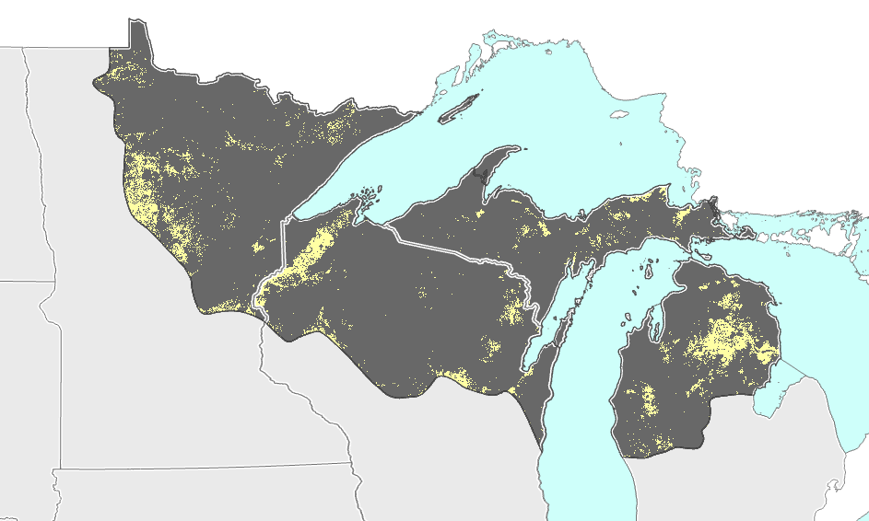
Historical Context
Prior to European colonization approximately 1.2M acres of the Northwoods were estimated to burn annually (from LANDFIRE Biophysical Settings Models and spatial data. Areas with an average of 1-10 years between fires were spread across the across the region (see Figure 1). Frequent fire areas were often dominated by oaks and pines with most fires being of the surface type (< 25% top kill).
Figure 1: Areas with historical fire return intervals of less than 10 years represented in yellow. Northwoods region in dark grey color.

Recent fires
Over 70k fires were reported in the Northwoods between 1992-2020, with most being small (< 10ac) and most occurring during April and May. While most fires have been small, there are notable exceptions such as the 2011 Cavity Lake Fire in MN/ON at > 32k ac and the 2012 Duck Lake Fire in MI at ~21k ac. Fires have been spread across the area, with the highest proportion of natural fires occurring in NE MN and the Upper Peninsula of MI.

Current risk
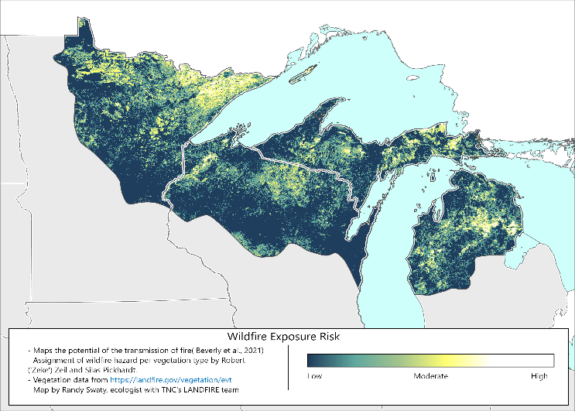
Using methods developed in Canada by Dr. Jennifer Beaverly, and LANDFIRE’s Existing Vegetation Type data we have mapped Wildfire Exposure Risk (WFE). The map highlights areas where wildfire transmission is most likely to occur in the event of an ignition. The areas with the highest WFE are generally in NE Minnesota, the eastern Upper Peninsula of Michigan and the north-central region of the Lower Peninsula of Michigan (see Figure 2). Roughly 8% of the area was classified as having Very High/High WFE.
Figure 2: WFE for the Northwoods.

